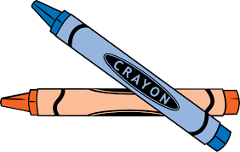

**Brentano Blended Preschool**

**Room 113**

**School Supply List**

* 1 large backpack with complete change of clothes (including underwear and socks – for water or paint spills)
* 2-3 picture of your family to place in our class family picture album
* 2 rolls of paper towels
* 2 dry erase EXPO markers
* 1 container of wipes
* 1 container of Clorox wipes
* Hand sanitizer (Purell foam)
* 1 box of Kleenex
* Scotch tape
* scissors (solid color)

|  |  |
| --- | --- |
| AM Students bring the following:   * 4 glue sticks (any size) | PM Students bring the following:   * 1 bottle of liquid glue (any size) |



**Preescolar de Brentano**

**Salón 113**

**Lista de útiles**

* 1 mochila grande con un cambio de ropa (incluyendo ropa interior y calcetines – para derrames de agua o pintura)
* 2-3 fotos de su familia para nuestro álbum de clase
* 2 rollos de papel of
* 2 marcadores EXPO
* 1 botella de toallas húmedas para cara y manos
* 1 botella de toallas húmedas Clorox
* desinfectante para manos (Purell foam)
* 1 caja de Kleenex
* cita adhesiva Scotch
* tijeras (de un solo color)

|  |  |
| --- | --- |
| Estudiantes de la mañana traigan:   * 4 barras de pegamento | Estudiantes de la tarde traigan:   * 1 botella de pegamento |